**Experiment 12 Date:** 11/04/2023

**Aim:**

Familiarization of Linux Commands

**Course Outcome(CO4):**

Write shell scripts required for system administration

**Procedure:**

1. Shell script to demonstrate String operators (Equal, Not Equals, Size is zero, Size is non-zero, Empty string) by taking user input

vi filename.sh

Press ‘i’ to INSERT

#!/bin/bash

read -p "Enter the first string: " str1

read -p "Enter the second string: " str2

if(( $str1=$str2 ))

then

echo "Both strings are equal"

else

echo "Both strings are not equal"

fi

if(( $str1!=$str2 ))

then

echo "Both strings are not equal"

else

echo "Both strings are equal"

fi

if(( -z$str1 ))

then

echo "String size is zero"

else

echo "String size is non-zero"

fi

if(( -n$str1 ))

then

echo "String size is non-zero"

else

echo "String size is zero"

fi

if(( $str1 ))

then

echo "String is Empty"

else

echo "String is not Empty"

fi

Press ‘Esc’ to end INSERT

:wq!

chmod +x filename.sh

./filename.sh

Output:

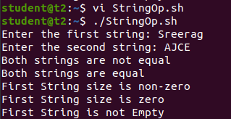

1. Shell script to demonstrate Bitwise operators (AND, OR, XOR, Complement, Right Shift, Left Shift) by taking user input

vi filename.sh

Press ‘i’ to INSERT

#!/bin/bash

read -p "Enter the first value: " bin1

read -p "Enter the second value: " bin2

result=$(( $bin1&$bin2 ))

echo "Bitwise AND: $result"

result=$(( $bin1|$bin2 ))

echo "Bitwise OR: $result"

result=$(( $bin1^$bin2 ))

echo "Bitwise XOR: $result"

result=$(( ~$bin1 ))

echo "Bitwise COMPLEMENT of First Value: $result"

result=$(( $bin1<<2 ))

echo "Bitwise RIGHT SHIFT(4) of First Value: $result"

result=$(( $bin1>>2 ))

echo "Bitwise LEFT SHIFT(4) of Second Value: $result"

Press ‘Esc’ to end INSERT

:wq!

chmod +x filename.sh

./filename.sh

Output:

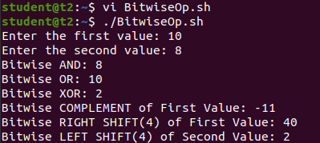

1. Shell script to demonstrate File Test operators (Exist(e), Size(s), Read Permission(r), Execute Permission(x), Write Permission(w)) by taking user input

vi filename.sh

Press ‘i’ to INSERT

#!/bin/bash

read -p "Enter file name: " f1

if [ -e $f1 ]

then

echo "$f1 exist"

else

echo "$f1 does not exist"

fi

if [ -s $f1 ]

then

echo "$f1 is not empty"

else

echo "$f1 is empty"

fi

if [ -r $f1 ]

then

echo "$f1 has read permission"

else

echo "$f1 does not have read permission"

fi

if [ -x $f1 ]

then

echo "$f1 has execute permission"

else

echo "$f1 does not have execute permission"

fi

if [ -w $f1 ]

then

echo "$f1 has write permission"

else

echo "$f1 does not have write permission"

fi

Press ‘Esc’ to end INSERT

:wq!

chmod +x filename.sh

./filename.sh

Output:

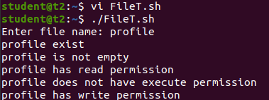

1. Shell Script to check if two numbers are equal using if statement

vi filename.sh

Press ‘i’ to INSERT

#!/bin/bash

read -p "Enter the first number: " num1

read -p "Enter the second number: " num2

if(( $num1==$num2 ))

then

echo "Both numbers are equal"

fi

if(( $num1!=$num2 ))

then

echo "Both numbers are not equal"

fi

Press ‘Esc’ to end INSERT

:wq!

chmod +x filename.sh

./filename.sh

Output:

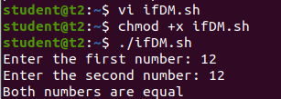

1. Shell Script to check the range of a number if numbers using else if ladder

vi filename.sh

Press ‘i’ to INSERT

#!/bin/bash

read -p "Enter the number(b/w 0-50): " num1

if(( $num1>=0&&$num1<=10 ))

then

echo "$num1 is between 0 and 10"

elif(( $num1>=11&&$num1<=20 ))

then

echo "$num1 is between 10 and 20"

elif(( $num1>=21&&$num1<=30 ))

then

echo "$num1 is between 20 and 30"

elif(( $num1>=31&&$num1<=40 ))

then

echo "$num1 is between 30 and 40"

elif(( $num1>=41&&$num1<=50 ))

then

echo "$num1 is between 40 and 50"

fi

Press ‘Esc’ to end INSERT

:wq!

chmod +x filename.sh

./filename.sh

Output:

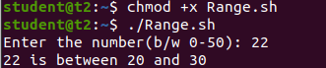

1. Shell Script to display the grade of a student by accepting his mark.

vi filename.sh

Press ‘i’ to INSERT

#!/bin/bash

read -p "Enter the Student name: " name

read -p "Enter the Mark of first subject: (Max : 50) " mark1

read -p "Enter the Mark of second subject: (Max : 50) " mark2

read -p "Enter the Mark of third subject: (Max: 50) " mark3

total=$(( mark1+$mark2+$mark3 ))

echo "Total Marks: $total"

if [ $total -le 50 ]

then

echo "Student scored grade F"

elif [ $total -le 85 ]

then

echo "Student scored grade D"

elif [ $total -le 105 ]

then

echo "Student scored grade C"

elif [ $total -le 130 ]

then

echo "Student scored grade B"

else

echo "Student scored grade A"

Press ‘Esc’ to end INSERT

:wq!

chmod +x filename.sh

./filename.sh

Output:

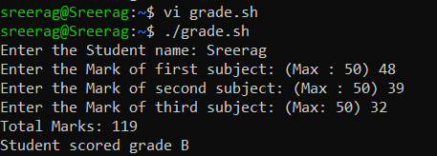

**Result:**

Output displayed successfully and CO4 was obtained.